William Watlington

August 14, 2022

WEB 335 – Introduction to NoSQL

Exercise 1.2 – GitHub Repository Setup

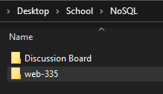Screenshot of local cloned directory:

\

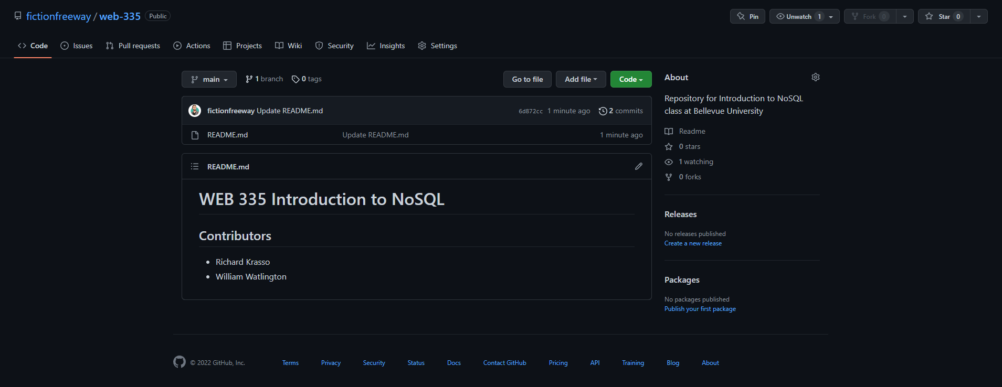Screenshot of GitHub repository:

Link to GitHub Repository:

<https://github.com/fictionfreeway/web-335>